

台州学院
《Java高级程序设计》
实验报告

实验项目: 实验5 过滤器和监听器配置与实现
学号姓名: 2X计奇2X00000000无名氏
专 业：计算机科学与技术
班 级：21计应1班
实验时间：第12-13次课 三/四/五

电子与信息工程学院

一、实验目的及要求：
1)使用filter和lisenlter技术, 实现对指定的内容进行过滤;
2)统计在线人数;
3)熟练使用filter过滤器和Lisentler监听器。

二、实验内容：
1.写一个Form，其中有一个text域comment，再写一个CommentServlet显示comment的内容。然后，写一个过滤器CommentFilter对comment的内容进行过滤，比如，如果有dog或者cat，为内容非法，则不让显示该评论内容comment，并显示”illegal comment”。再写一个过滤器CommentSizeFilter对comment的内容的字符长度进行过滤，比如，如果超过10个字符就为长度非法，则不让评论内容comment显示，并显示”size illegal”。
2.使用监听器，统计在线人数。

三、实验代码及运行结果（包括可能有的截图）：

1

CommentFilter

package servlet;

import javax.servlet.*;

import javax.servlet.annotation.*;

import javax.servlet.http.HttpServletRequest;

import javax.servlet.http.HttpServletResponse;

import java.io.IOException;

import java.io.PrintWriter;

@WebFilter(filterName = "f1contentfilter",urlPatterns = "/comment")

public class CommentFilter implements Filter {

public void destroy() {

System.out.println("destroy...");

}

@Override

public void doFilter(ServletRequest arg0, ServletResponse arg1, FilterChain agr2) throws ServletException, IOException {

System.out.println("CommentSizeFilter's doFilter..");

HttpServletRequest request=(HttpServletRequest)arg0;

HttpServletResponse response=(HttpServletResponse)arg1;

PrintWriter out=response.getWriter();

String comment=request.getParameter("comment");

String illegalStr="dog";

if(comment.indexOf(illegalStr)>=0){

out.println("<h1>illegal comment</h1>");

return ;

}

agr2.doFilter(request, response);

out.println("<h1>CommentFilter's doFilter has executed</h1>");

}

public void init(FilterConfig arg0) throws ServletException {

/*System.out.println("init...");

config=arg0;*/

}

}

CommentServlet

package servlet;

import javax.servlet.*;

import javax.servlet.http.*;

import javax.servlet.annotation.*;

import java.io.IOException;

import java.io.PrintWriter;

@WebServlet("/comment")

public class CommentServlet extends HttpServlet {

@Override

protected void service(HttpServletRequest request, HttpServletResponse response) throws ServletException, IOException {

response.setContentType("text/html");

PrintWriter out=response.getWriter();

String comment=request.getParameter("comment");

out.println("<h1>"+comment+"<h1>");

}

}

CommentSizeFilter

package servlet;

import javax.servlet.*;

import javax.servlet.annotation.*;

import javax.servlet.http.HttpServletRequest;

import javax.servlet.http.HttpServletResponse;

import javax.servlet.http.HttpSession;

import java.io.IOException;

import java.io.PrintWriter;

@WebFilter(filterName = "f2contentfilter",urlPatterns = "/comment")

public class CommentSizeFilter implements Filter {

public void init(FilterConfig config) throws ServletException {

}

public void destroy() {

}

@Override

public void doFilter(ServletRequest arg0, ServletResponse arg1, FilterChain agr2) throws ServletException, IOException {

System.out.println("CommenstSizeFilter's doFilter..");

HttpServletRequest request=(HttpServletRequest)arg0;

HttpServletResponse response=(HttpServletResponse)arg1;

PrintWriter out=response.getWriter();

String comment=request.getParameter("comment");

if(comment.length()>20){

out.println("<h1>comment's size is illegal</h1>");

return ;

}

agr2.doFilter(request, response);

System.out.println("after fi size doFilter()");

}

}

长度违法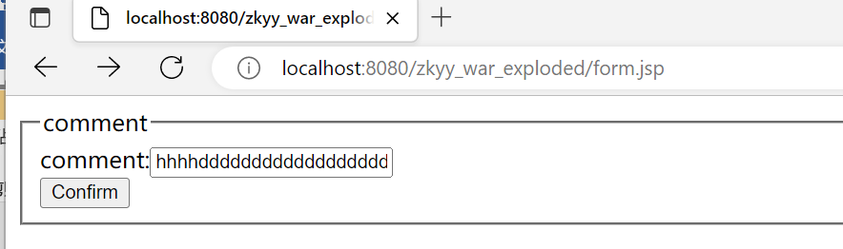

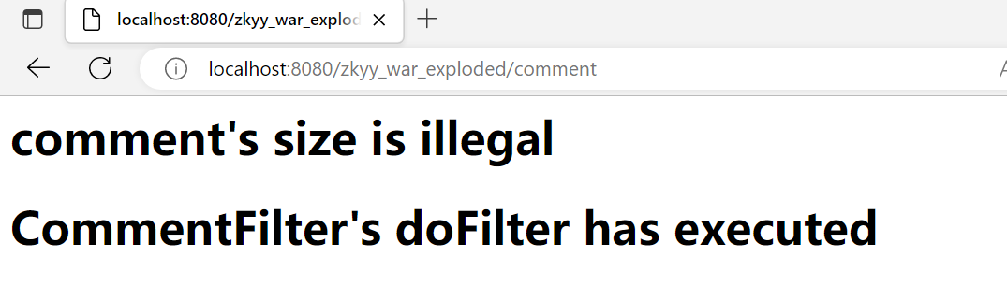

成功发送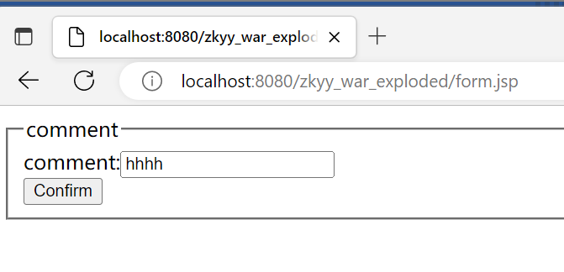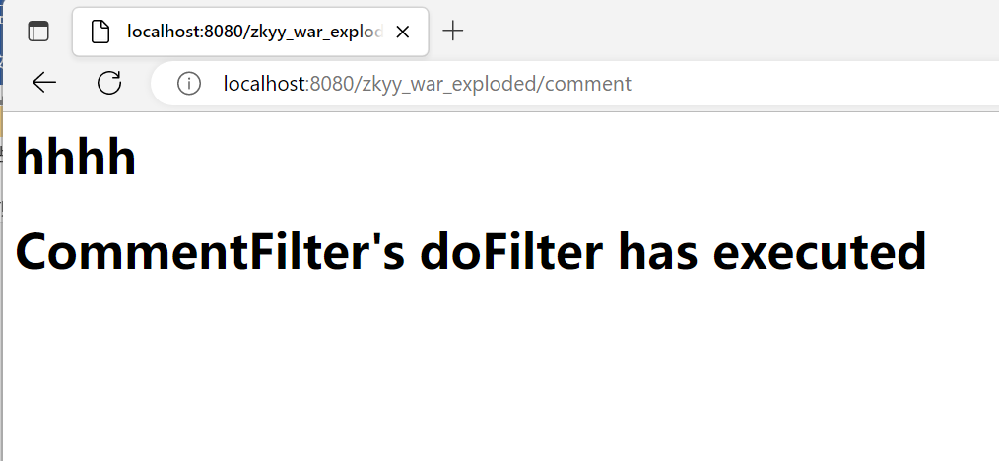

内容不合格

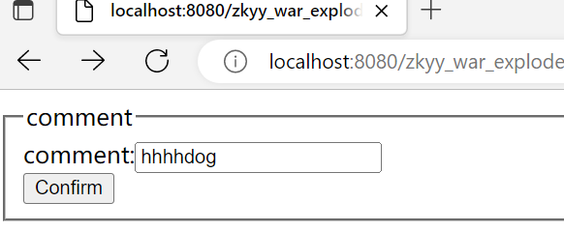

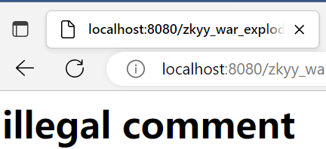

2.
package servlet;

import javax.servlet.ServletContext;
import javax.servlet.http.HttpSessionEvent;
import javax.servlet.http.HttpSessionListener;

public class CountListener implements HttpSessionListener{
private int count;
public void sessionCreated( HttpSessionEvent arg0) {
System.out.println("sessionCreated...");
count++;
ServletContext sctx = arg0.getSession().getServletContext();
sctx.setAttribute("count", count);
}

public void sessionDestroyed(
HttpSessionEvent arg0) {
System.out.println("sessionDestroyed...");
count--;
ServletContext sctx = arg0.getSession().getServletContext();
sctx.setAttribute("count", count);
}

}
package servlet;

import java.io.IOException;
import java.io.PrintWriter;

import javax.servlet.ServletContext;
import javax.servlet.ServletException;
import javax.servlet.http.HttpServlet;
import javax.servlet.http.HttpServletRequest;
import javax.servlet.http.HttpServletResponse;

public class OneServlet extends HttpServlet {

public void service(HttpServletRequest request, HttpServletResponse response)
throws ServletException, IOException {
ServletContext sctx = getServletContext();
String version = sctx.getInitParameter("version");
System.out.println("version:" + version);
sctx.setAttribute("somekey2", "somedata2");
System.out.println("set somekey2 to servletContext");
}

@Override
public void init() throws ServletException {
ServletContext sctx = getServletContext();
sctx.setAttribute("somekey", "somedata");
System.out.println("set somekey to servletContext");

}

}
ackage servlet;

import java.io.IOException;
import java.io.PrintWriter;

import javax.servlet.ServletContext;
import javax.servlet.ServletException;
import javax.servlet.http.HttpServlet;
import javax.servlet.http.HttpServletRequest;
import javax.servlet.http.HttpServletResponse;

public class TwoServlet extends HttpServlet {
public void service(HttpServletRequest request, HttpServletResponse response)
throws ServletException, IOException {
ServletContext sctx = getServletContext();
String version = sctx.getInitParameter("version");
System.out.println("version:" + version);

String data = (String)sctx.getAttribute("somekey");
response.setContentType("text/html");
PrintWriter out = response.getWriter();
out.println("<h1>" + version + "</h1>");
out.println("<h1>" + data + "</h1>");

String data2 = (String)sctx.getAttribute("somekey2");
out.println("<h1>" + data2 + "</h1>");

out.close();
}

}

监听人数
